

mobiVUE PMMS (Pharmaceutical Manufacturing Management System)

Ajanta Pharma Limited

**Version: 1.0**

The document details the summary of solution architecture and approach for the development of mobiVUE PMMS for Ajanta Pharma Limited. The document is based on the visit to the Guwahati plant of Ajanta Pharma Limited and inputs gathered, discussions held between BCI & Ajanta Pharma Limited.

This document will represent the Warehouse module covering below modules

1. Gate Entry
2. Vehicle Inspection
3. Material Inspection
4. Material Label Printing
5. Palletization
6. Put Away
7. Bin to Bin Transfer

*Note: This may not be a comprehensive report and needs verification and confirmation by Ajanta Pharma Limited.*

Project Scope: Warehouse Module (Receiving)

Software Requirement Specification (SRS)

BAR CODE INDIA, 145 Udyog Vihar Phase 1, Gurugram, Haryana-122016, PH: 0124 4337555

**Prepared By: Abhishek P Palwankar**

|  |  |  |  |  |
| --- | --- | --- | --- | --- |
| REVISION NO. | DATE | PREPARED BY | REVIEWED BY | COMMENT |
| 1 | 1-03-2021 | Abhishek P Palwankar | Hamir Thakur | Initial Document |

REVISION HISTORY

**Abbreviations:**

**Client: Ajanta Pharma Limited**

**Vendor:** Bar Code India, henceforth, will be referred as BCI.

Notice:

This document contains information, which is the proprietary property of Bar Code India. This document is received in confidence and its contents cannot be disclosed or copied without the prior written consent of Bar Code India.

Nothing in this document constitutes a guaranty, warranty, or license, express or implied. Bar Code India disclaims all liability for all such guaranties, warranties, and licenses, including but not limited to: Fitness for a particular purpose; merchantability; not infringement of intellectual property or other rights of any third party or of Bar Code India; indemnity; and all others. The reader is advised that third parties can have intellectual property rights that can be relevant to this document and the technologies discussed herein and are advised to seek the advice of competent legal counsel, without obligation of Bar Code India.

Bar Code India retains the right to make changes to this document at any time, without notice. Bar Code India makes no warranty for the use of this document and assumes no responsibility for any errors that can appear in the document nor does it make a commitment to update the information contained herein.

COPYRIGHT

Copyright © ***BCI*** 2021. All rights reserved.

TRADEMARKS

*Other product and corporate names may be trademarks of other companies and are used only for explanation and to the owners' benefit, without intent to infringe.

Table of Contents

1 Specification Organization 1

2 Introduction 2

2.1 Intended Audience and Reading Suggestions 2

2.2 Project Scope mobiVUE PMMS 3

3 Software/Hardware Requirements 4

3.1 Plant Server (Both DB and Application) 4

3.2 Desktop Computers 4

3.3 Hardware Requirements 4

4 User Interface Specification Conventions 5

5 System Log 6

5.1 Error Logs 6

6 Architectural Design 7

6.1 Web Services 7

6.2 Device Application 7

6.3 Web Application 7

7 Application Modules 8

7.1 Application Login 8

7.2 Warehouse Process 9

7.2.1 Gate Entry 9

7.2.2 Vehicle Inspection 11

7.2.3 Material Inspection 13

7.2.4 Material Label Printing 15

7.2.5 Palletization 20

7.2.6 Put Away 22

7.2.7 bin to Bin Transfer 25

7.2.8 Reports 27

8 SRS Scope Change Process 28

8.1 Before Sign Off 28

8.2 After Sign Off 28

8.3 SRS Acceptance 28

# Specification Organization

The objective of this document is to provide underlying concepts, procedures, and formats used in the design, development and installation of this software application. This specification consists of three sections organized as follows:

**Section 1: Introduction**

This section provides hardware requirements and documentation conventions.

**Section 2: User Interface**

This section depicts screen design and logic flow, and is categorized into two groups:

* Application Function Module
* Common Routine

**Section 3: System Architecture**

This section provides information of system architecture.

# Introduction

## Intended Audience and Reading Suggestions

The scope of this document is to provide the understanding of this solution to user & development teams associated with the application development & implementation.

This document major emphasizes on providing clear understanding **of mobiVUE PMMS**

This solution comprises of:

* Web Application
* Mobile Device Application
* Web Services
* SAP Interfaces

## Project Scope mobiVUE PMMS

The project scope is to develop and implement the Automation System at Warehouse, Manufacturing and Finish Goods for Ajanta Pharma Limited, the solution will facilitate user to manage the storage of inventory at warehouse and also helps in efficient allocation of Material for Sampling and Dispensing. Barcode Labels will be generated for the received Material Packaging i.e. Containers or Bags against the Gate Entry Number; the application also provides identification for Equipment, Dispensing Booths, Weighing Machine, In-process machines, Pallets, Trolleys and process/dispensing rooms.

The application will be integrated with the Weighing Machine which will help to capture weight automatically, this help as it provides control on inventory as no wrong Material or quantity can be issued.

The system will be integrated with the SAP and will control the flow of information from application to database and vice- versa. Each and every transaction will be recorded along with the time stamp which will help user to access any process related information as and when required.

This would require development of Wi-Fi enabled application for real time transactioni.e.the data will be captured in real-time, once the data has been collected, the database can then provide useful reports about status of material.

The entire solution consists of followings:

* Web Application
* Mobile Device Application
* Web Services
* SAP Interface with PI Server

# Software/Hardware Requirements

Below are the hardware and the software requirements of the application:

*TO BE CHANGED AS PER APPLICATION REQUIREMENT

## Plant Server (Both DB and Application)

The solution would require the high performance server with minimum following:

Server will be placed as 1 for prod & 1 for DEV/QA

|  |  |
| --- | --- |
| **Descriptions** | **Qty** |
| HPE DL20 Gen10 4SFF SERVER : 1 x INTEL XEON E-2136 6C 3.3GHz Processor rail kit, 1xLP riser, HP drive cage | 1 |
| HPE 16GB 2Rx8 PC4-2666V-E STND Kit | 2 |
| HPE 1TB SATA 7.2K SFF SC DS HDD | 2 |
| HPE 500W FS Plat Hot Plug LH Power Supply Kit | 2 |
| 3years 4hour response 24x7 warranty | 1 |

## Desktop Computers

Desktop would require following specifications:-

* I3/i5 Processor with Windows 7 operating System
* 16 GB RAM
* 100GB HDD
* Dot net Framework 4.0

## Hardware Requirements

Hardware required for the application:

* Android Mobile Device
* Zebra Barcode Label Printer

# User Interface Specification Conventions

This section specifies the user interface portion of the application.

**Section Organization**

The User Interface Specification presents screen displays or “**Dialogs**”.

**Documentation Conventions**

This section incorporates illustrations of the application user interface. Each screen display “Dialog” consists of the screen display image, a process name, a paragraph documenting the processing required for the dialog, a paragraph listing the navigation options, and a table listing for each variable field on the dialog, its database source or destination, format, and any instructions required to process the field.

The following section contains a sample dialog with each area identified.

# System Log

System shall maintain internal logs for application.

## Error Logs

These logs will contain any errors encountered during runtime for faster resolution of any problem post deployment.

# Architectural Design

*TO BE CHANGED AS PER SYSTEM REQUIREMENT

Overall System consists of:

* Web Application
* Device Application
* Web Services

## Web Services

This application will handle the device request in real time. Most of business logic on scanning will run on this module. Web Service will be hosted in IIS Services, Web Services will run on central server.

## Device Application

This application will include warehouse process modules. Application will directly communicate with user input and process the request to communication server.

## Web Application

A Web Application will be developed using which users will create the master data, download details from SAP, prints item barcode label etc. It also helps to generate and display related transaction reports to End Users in real time.

# Application Modules

## Application Login

This login module will provide access to the application modules. Here the admin/user needs to enter the login detail to enter in the application and to perform the desired actions.

**Process:** User needs to enter the User Name/ID and Password in display fields and press the Login button. Application will validate the user credential.

*User will be able to view only those screens/ modules of which he has been given access rights to.*

**Validation**

* User Name/ ID will be unique for all users.
* User Name/ ID and Password length will be set.

After successful login application menu screen will appear; this screen will have the Master and Transaction options etc.

## Warehouse Process

### Gate Entry

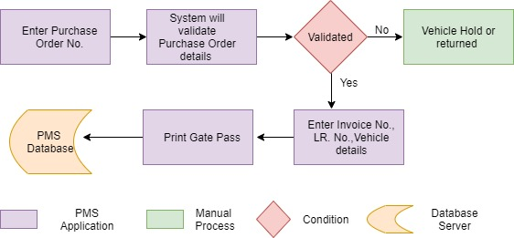

**Activities**

|  |  |
| --- | --- |
| **Module Description** | Gate pass activities controls and manage the external vehicle movement inside the plant for unloading the material |

|  |  |
| --- | --- |
| **Pre-Conditions** | Purchase Order details needs to be imported from SAP. |

|  |  |
| --- | --- |
| **Process Steps** | 1. Gate Entry:    1. Security Personnel will login into PMMS Application.    2. In Gate Entry module enter the purchase order no. mentioned on Invoice.    3. System will display details :       1. Purchase order No.       2. Purchase Order Date       3. Material Code       4. Material Description (Multiple Materials)       5. Vendor Name    4. Security Personnel will verify all details physically    5. Enter following details in PMMS application       1. Invoice no.       2. Invoice Date       3. Transporter Name (Master from SAP)       4. LR No.       5. LR Date       6. Driver Name.       7. Vehicle no.    6. Gate Pass No. will be generated.    7. Then print Gate Pass (Inward).    8. Barcode will be printed on Gate pass.    9. If there is any mismatch while physical verification and vehicle needs to be hold then security person will enter remark and Gate pass will not be printed.   ***Note:*** *item having purchase order in SAP only can be used here and gate pass for that can be printed.* |

|  |  |
| --- | --- |
| **Post-Conditions** | 1. Gate Pass barcode should be available at the unloading bay. |

|  |  |
| --- | --- |
| **Validations** | 1. Purchase Order No. entered is valid, entered by security Personnel 2. Duplicate Gate Pass can’t be generated however can be reprinted on authorization. |
| **Sample Screen Design** | |  |  |  |  |  | | --- | --- | --- | --- | --- | | Gate Entry | | | | | | |  |  |  |  |  | | Purchase Order | |  |  |  | |  |  |  |  |  | | Purchase Order Date | | |  |  | |  |  |  |  |  | | Material Description | | |  |  | |  |  |  |  |  | | Vendor Name |  |  |  |  | |  |  |  |  |  | | Invoice No | |  |  |  | |  |  |  |  |  | | LR. No. |  |  |  |  | |  |  |  |  |  | | Driver Name | |  |  |  | |  |  |  |  |  | | Vehicle No. | |  |  |  | |  |  |  |  |  | |  | Print |  | Close |  | |  |  |  |  |  | |

Changes

### Mainly It was a design and flow that we changed after discussion.

### Vehicle Inspection

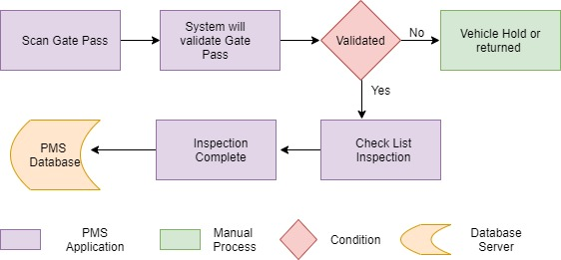

**Activities**

|  |  |
| --- | --- |
| **Module Description** | Before unloading material from the vehicle, vehicle will be inspected against the defined checklist. |

|  |  |
| --- | --- |
| **Pre-Conditions** | 1. Gate Pass to be printed while Gate entry and same to be provided while unloading. 2. Checklist is available in checklist master. |

|  |  |
| --- | --- |
| **Process Steps** | 1. Gate Pass printed at Gate will be provided by driver. 2. Vehicle inspection user will login in PMMS application. 3. Scan the Gate Pass and system will display details    1. PO No.    2. Gate Pass No.    3. Invoice No.    4. Invoice Date    5. Transport Name    6. LR No.    7. LR Date    8. Driver Name    9. Vehicle No.    10. Vendor Name 4. And also display checklist for inspection of vehicle from Check List Master. 5. User will verify the checklist physical and also update the in PMMS application by click on OK or Not OK 6. If there is any discrepancy then user will enter in discrepancy remark. 7. If the verification is passed then material inspection will be done else it will be returned. |

|  |  |
| --- | --- |
| **Post-Conditions** | 1. Material inspection will be done. |

|  |  |
| --- | --- |
| **Validations** | 1. Gate Pass scanned is valid and inspection is not already completed. |
| **Sample Screen Design** |  |

Changes

* Removed Overall Discrepancy Remark
* Added Remark individual Checkpoint level
* Added Checklist Type before selecting Inspection checklist
* Changed checkpoint feature

### Material Inspection

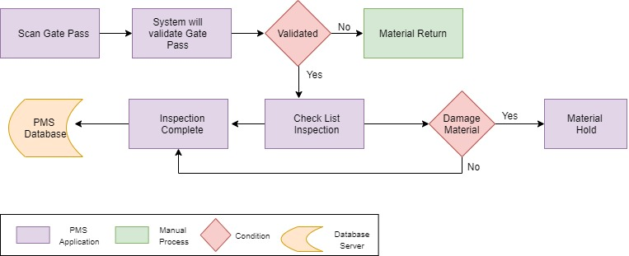

**Activities**

|  |  |
| --- | --- |
| **Module Description** | Visual Material Inspection is the process where material is inspected after the material has arrived, mostly from outside plant (from Vendor, other plants etc.) |

|  |  |
| --- | --- |
| **Pre-Conditions** | 1. Gate Pass Should be available for scanning 2. Vehicle Inspection is completed |

|  |  |
| --- | --- |
| **Process Steps** | 1. Gate Pass printed at Gate will be provided by driver. 2. Material inspection user will login in PMMS application. 3. Scan the Gate Pass and system will display details    1. Invoice No.    2. LR No.    3. Driver Name    4. Vehicle No.    5. Vendor Name    6. Mfg. Name 4. And also display checklist for inspection of Material from Check List Master. 5. User will verify the checklist physical and also update the in PMMS application by click on Yes or No 6. If the verification is passed then material inspection will be done else it will be returned. 7. **Damage Material:**    1. If any material is found damage then remark will be mentioned against the same.    2. User will select the material code, Vendor Batch No. and mention no. of container damage and also the quantity. |

|  |  |
| --- | --- |
| **Post-Conditions** | 1. Weighing and Barcode Labeling of the material. 2. Identifying each container uniquely. |

|  |  |
| --- | --- |
| **Validations** | 1. Gate Pass scanned is valid and inspection is not already completed 2. Remark will be mandatory for damaged container. |
| **Sample Screen Design** |  |

Changes

* Added Remark individual Checkpoint level
* Added Checklist Type before selecting Inspection checklist
* Added below details at Material level
  + Consignment Details
  + Checkpoints
  + Damage
* Showing only valid batch no to declare damage. (Batch no, which are added at consignment level)
* Changed checkpoint feature

### Material Label Printing

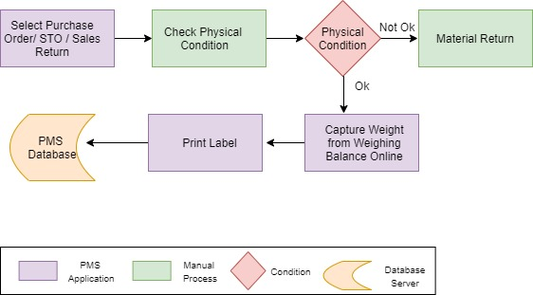

**Activities**

|  |  |
| --- | --- |
| **Module Description** | The Module will be used to capture weight and print material label for each container |

|  |  |
| --- | --- |
| **Pre-Conditions** | 1. Purchase Order/STO/ Sales Return should be downloaded in PMMS application via WEB API. 2. Material should not be in damaged condition 3. Material Inspection needs to be completed |
| **Process** | 1. As the material inspection is completed each container will be weighed. 2. Label will be printed with weight printed on it. 3. No. of container weighing will be decided as mentioned in SOP. 4. After completing weighing, system store the data and GRN will be posted. 5. From PMMS application posting of GRN to SAP will be done 6. SAP will generate GRN No. and share the same with PMMS application 7. Then Material label with GRN Details (GRN No., Material Code, SAP Batch No.) will be printed and no. of container will be printed as mentioned in GRN. 8. **3 different forms for label printing**    1. Weight Capture    2. GRN Posting    3. Label Printing |

|  |  |
| --- | --- |
| **Process Steps** | 1. User will login in the PMMS application 2. **Weight Capture**    1. Select the Purchase order/ STO/ Sales Return and system will display details.    2. Enter Manufacturing Batch No., Expiry Date (NA in case of blank), Mfg. Date (NA in case of blank), Retest Date (NA in case of blank) and No. of Containers.    3. User will select he UOM from the List (Kg, G, Mg, L, ML, EA, Nos, TH).    4. As per the UOM selected system will display quantity to be capture in Gross, Net and tare or in No. of Packs.    5. **Weighing Process:** 3. User place the container on the weighing balance. 4. Scan the weighing balance barcode and capture Gross weight through LAN. 5. System will display the weight in PMMS application. 6. Capture Gross wt. then enter Tare wt. (Refer Vendor label) and then system will calculate Net wt.   **Or**   1. Capture Gross wt. then enter Net wt. (Refer Vendor label) and then system will calculate Tare wt.    1. **No. of Packs**       1. User count the no. of packs and enter the Quantity in Kg, G, Mg, L, ML, EA, Nos, TH. (Refer Vendor label as applicable) 2. **GRN Posting**    1. Enter Purchase order no. and system will display details.    2. Enter Material consignment quantity and then enter number of container and also enter single container weight.    3. System will calculate and assign the weight for each container.    4. User will both for intact container as well as partial.    5. For partial system will create new line item. 3. **Label Printing**    1. User will select/Enter GRN No. in PMMS application using Tablet/Device.    2. GRN details will be displayed on screen.    3. User will verify the details and click on “**Print**” button in PMMS application using Tablet/Device    4. As per the No. of Containers mentioned that many count of Material label will be printed (As Material Label Design mentioned in design tab). 4. Barcode with Unique ID will be printed and user will apply on container. 5. This process will be applicable for all Raw Materials and Packing Material. 6. Printing, Scanning details and weight capture will be stored in PMMS Database.   **Receiving Conditions**   1. **Raw Material**   Materials will be weighed as mentioned in SOP, and user will mention the consignment quantity. System will calculate and equally allocate the weight to each container, and print same on each label.   1. **Rolls**   Materials will be weighed as mentioned in SOP, and user will mention the consignment quantity. System will note the quantity of that particular container and print consignment quantity on label. |

|  |  |
| --- | --- |
| **Post-Conditions** | 1. Label should get generated as per defined logic. |

|  |  |
| --- | --- |
| **Validations** | 1. Application will validate input data i.e. text field values and selections. 2. Only authorized users should be allowed to access the application else an error message should be displayed on screen. 3. An alert message is displayed in case of any error / invalid activity. 4. An alert should be displayed in case of any error during label printing. 5. System on will validate the weight mentioned document and actual weight captured. 6. Will not allow multiple posting to SAP. |

|  |  |
| --- | --- |
| **Detailed Label Description** | 1. Labels will be printed via Thermal Printer. 2. Transformative should provide WEB API Service to fetch PO details from ERP. 3. Re-Printing module will be provided for re-printing Material Labels. 4. *Barcode Label Size would be 4” * 6” in size* 5. *Material Barcode Label should be generated based on the logic defined in backend having following nomenclature* 6. *Font Size = 8 and Font Style = “Zebra Triumvirate”*   *Material Code + SAP Batch No. + Serial Number*  *Bifurcation of SKU Barcode Data*  *Material Code: 18 Digits*  *SAP Batch Number: 12 Digits*  *Serial Number: 6 Digits* |
| **Sample Screen Design** |  |

Changes

* UI was restructured after the discussion

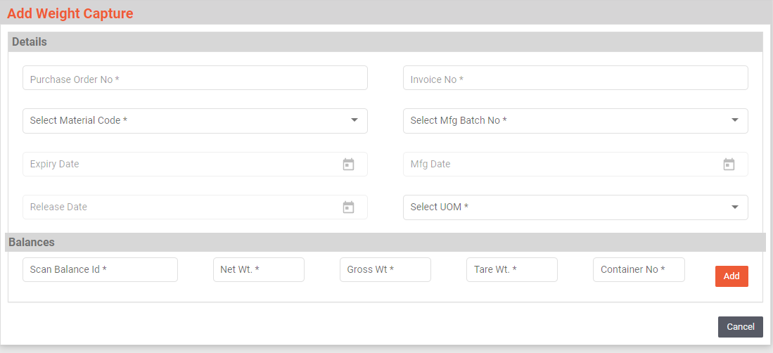

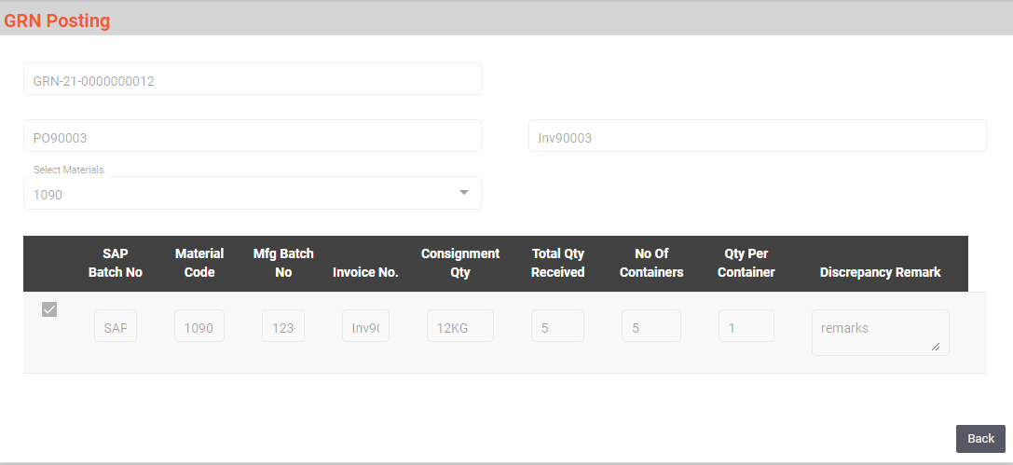

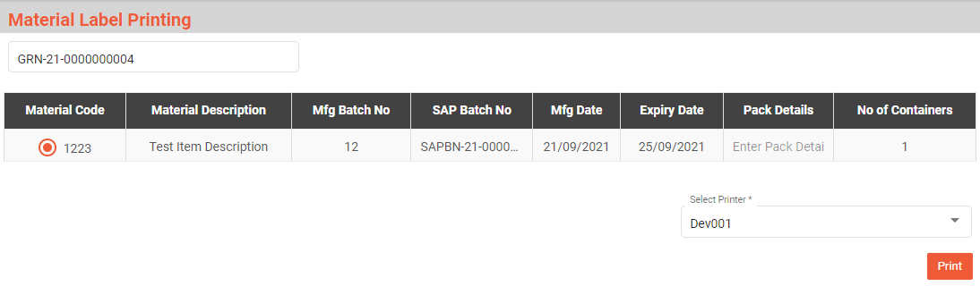

### Palletization

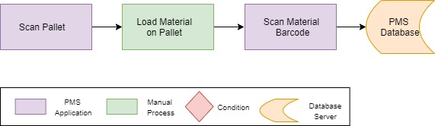

**Activities**

|  |  |
| --- | --- |
| **Module Description** | This module will be used to map pallet and material containers placed on pallet. |

|  |  |
| --- | --- |
| **Pre-Conditions** | 1. Material weights are captured and labels are applied on each container. 2. Material is ready for palletization. 3. Pallet should have barcode. |

|  |  |
| --- | --- |
| **Process Steps** | 1. While palletization user will place one by one container on the pallet. 2. User will login the PMMS application. 3. User will first scan the pallet barcode in the PMMS application. 4. Then as the container is placed on pallet scan material barcode. 5. System will map pallet and material barcode. 6. Count of container placed on pallet will be displayed on screen, on every scan count will be added and displayed. 7. **Remove from Pallet**    1. For any reason if the palletized material needs to be removed from pallet then scan the pallet barcode click on “Removed” button and scan the material barcode    2. Mapping of the pallet and material will be removed. |

|  |  |
| --- | --- |
| **Post-Conditions** | 1. Move for Put away in warehouse. |

|  |  |
| --- | --- |
| **Validations** | 1. Duplicate scanning of material barcode will not be allowed. 2. Only palletized material can be scanned in removed option. |
| **Sample Screen Design** |  |

Changes

* Partition in Pallet was discussed and added. User can add maximum 6 partition.
* Unique combination of MaterialCode+SAPBatch will be treated as 1 partition.

### Put Away

1. **Pallet to Bin**

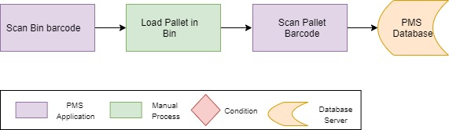

1. **Material to Bin**

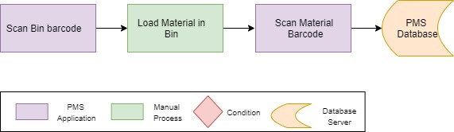

**Activities**

|  |  |
| --- | --- |
| **Module Description** | This module will be used to map Pallet, Material to Bins, material and pallet placed in Bins will be mapped. |

|  |  |
| --- | --- |
| **Pre-Conditions** | 1. Material weights are captured and labels are applied on each container. 2. Palletization is completed. 3. Material, Pallet is ready for put away. |

|  |  |
| --- | --- |
| **Process Steps** | 1. Put Away can be done in two ways.    1. **Pallet to Bins**       1. Palletized material will be placed in to Bins, will be scanned in this option.       2. User will login in the PMMS application.       3. User will scan the Bin barcode and then scan Pallet Barcode.       4. Scanning will be done using Mobile devices.       5. System will map Pallet and Bin.    2. **Material to Bins**       1. Material which are placed directly in bin without palletization will be scanned in this option       2. User will login in the PMMS application.       3. User will scan the Bin barcode and then scan Material Barcode.       4. Scanning will be done using Mobile devices.       5. System will map Material and Bin. |

|  |  |
| --- | --- |
| **Post-Conditions** | 1. Material are allocated in bins. |

|  |  |
| --- | --- |
| **Validations** | 1. Duplicate scanning of material barcode will not be allowed. 2. Once material put away is done it can be removed with Bin-Bin transfer only. |
| **Sample Screen Design** | 1. Pallet to Bin      1. Material to Bin |

### bin to Bin Transfer

**Activities**

|  |  |
| --- | --- |
| **Module Description** | This module will be used to transfer material or pallet from one bin to other. |

|  |  |
| --- | --- |
| **Pre-Conditions** | 1. Material is allocated in Bins. |

|  |  |
| --- | --- |
| **Process Steps** | 1. Bin to Bin Transfer can be done in two ways.    1. **Pallet to Bins Transfer**       1. Complete Pallet is to be transferred from one bin to other then this option will be used.       2. User will login in the PMMS application.       3. User will scan the Bin barcode in which pallet needs to be transferred and then scan Pallet Barcode.       4. Scanning will be done using Mobile devices.       5. System will map Pallet and Bin.    2. **Material to Bins Transferred**        1. Material container which needs to be transferred from one location to other then this option will be used.       2. User will login in the PMMS application.       3. User will scan the Bin barcode in which material container needs to be transferred and then scan material Barcode.       4. Scanning will be done using Mobile devices.       5. System will map Material and Bin. |

|  |  |
| --- | --- |
| **Post-Conditions** | 1. Material are transferred from one bin to other bins. |

|  |  |
| --- | --- |
| **Validations** | 1. Duplicate scanning of material barcode will not be allowed. 2. Allocated material can only be transferred. |
| **Sample Screen Design** | 1. **Pallet to Bins Transfer**      1. **Material to Bins Transferred** |

### Reports

Reporting module will provide access to the data that will be helpful in making well-informed strategic decisions, reduces risk, and increases productivity. The reporting interface will be user-friendly, application users can easily generate, and view required data.

The application will generate customized reports based on required data fields and time interval selected / entered by users; Microsoft Crystal Reports/ RDLC Reports will be generated which can be exported into defined excel file/ PDF format as and when required.

Reports can be defined as private for restricted viewing – or made public, giving access to information based on access rights assigned to the particular user / group.

1. Gate Entry Report
2. Material and Vehicle Inspection Report
3. Label Printing
4. Allocation Report
5. Bin to Bin Transfer

# SRS Scope Change Process

## Before Sign Off

Any changes in SRS need to be informed in writing by Company Name. It will be incorporated / confirmed only after doing detailed feasibility study by BCI.

## After Sign Off

Any changes in proposed solution after approval of this document by Ajanta Pharma Limited are subjected to confirmation from BCI, taking feasibility constraints into account. These changes will be incorporated (if any) into the solution only after delivering proposed solution & may be charged as extra.

The changes in proposed solution before & after acceptance will be mutually agreed and duly signed and accepted by Ajanta Pharma Limited & BCI.

## SRS Acceptance

Agreed and Accepted by Ajanta Pharma Limited and Bar Code India

|  |  |  |  |  |  |
| --- | --- | --- | --- | --- | --- |
| **Prepared by:**  **BCI** | **Name: Abhishek P Palwankar** | **Signature** |  | **Date:** |  |
| **Core Team :** | **Name:** | **Signature** |  | **Date:** |  |
| **Process Owner:** | **Name:** | **Signature** |  | **Date:** |  |
| **Approved by:**  **QA** | **Name:** | **Signature** |  | **Date:** |  |